Hands-on Exercise No. 4– Solution
AI Using Python
DigiSkills 3.0 Batch-03

1. Data Loading and Preprocessing:
• Load the Fashion-MNIST dataset from keras datasets
• Load the training and test images along with their labels
• Normalize the pixel values to the range [0, 1]
• Reshape the images appropriately for input to a CNN (e.g., (28, 28, 1) for grayscale
images)
• Provide a few sample images with their corresponding labels.
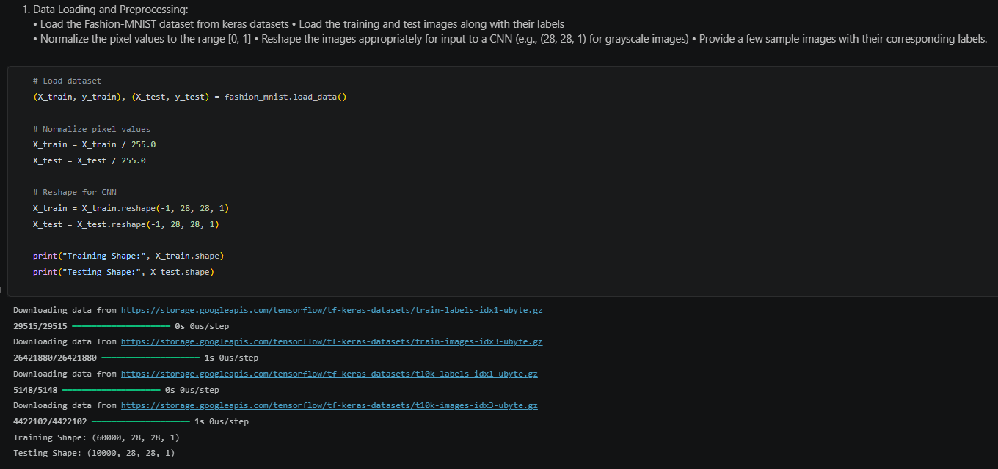
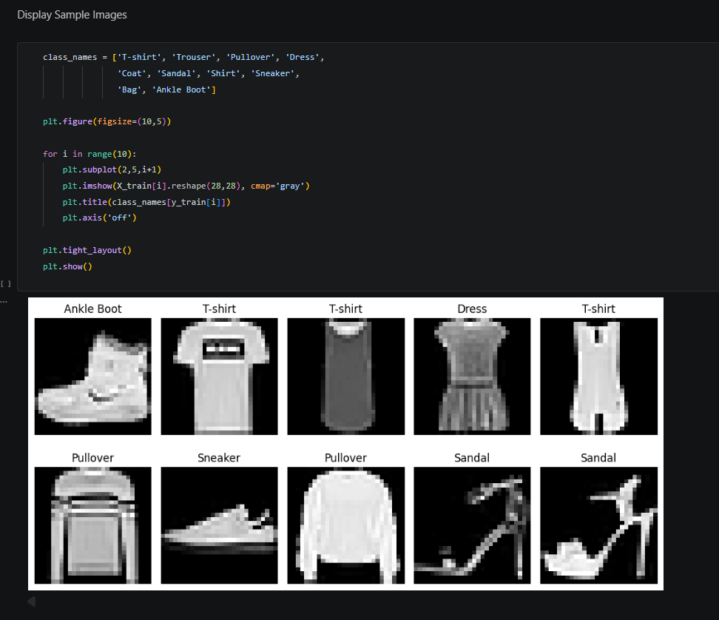
2. Design / Build the CNN Model: (Marks 2)
• Design a multi-layer Convolutional Neural Network using TensorFlow/Keras
• Include at least:
o 2 convolutional layers
o MaxPooling layers
o Dropout for regularization
o Flatten layer before the dense layers
o Dense layers leading to the output layer
• Compile the model using an appropriate optimizer, loss function, and evaluation metric for
Classification
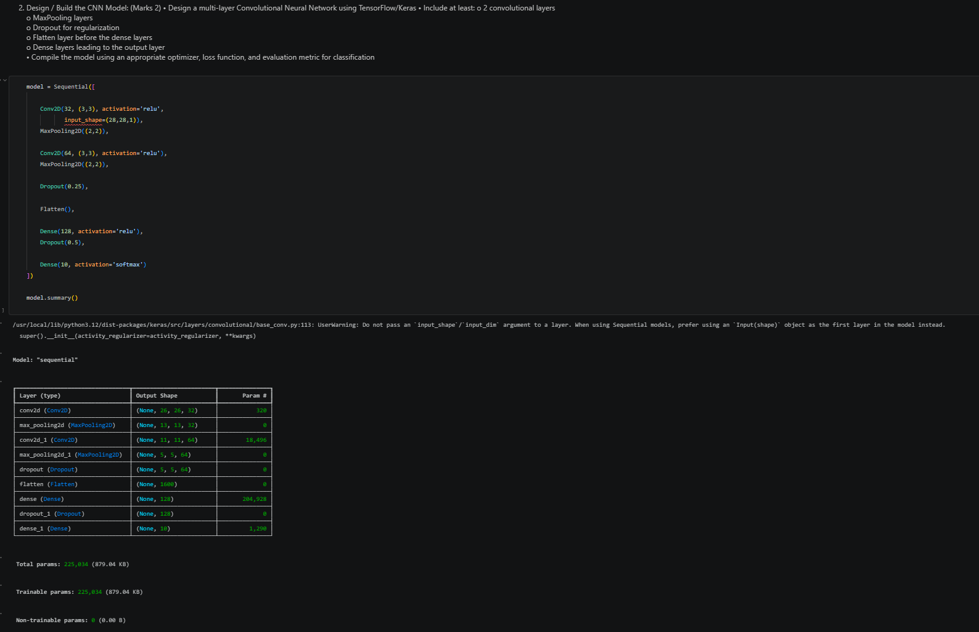
3. Compile and Train your Model: (Marks 2)
• Train the CNN using the training dataset
• Use a validation split (e.g., 10–20%) to monitor the model performance during training
• Train the model for a sufficient number of epochs to achieve stable accuracy
• Display the training and validation accuracy/loss per epoch
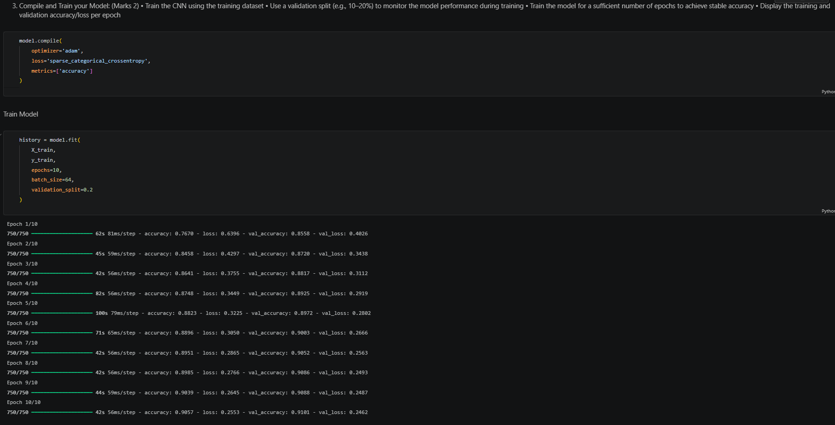
4.ModelEvaluation: • Evaluate the trained model on the unseen test dataset
• Report the test accuracy and loss
• Generate a confusion matrix and classification report showing performance on different
fashion categories
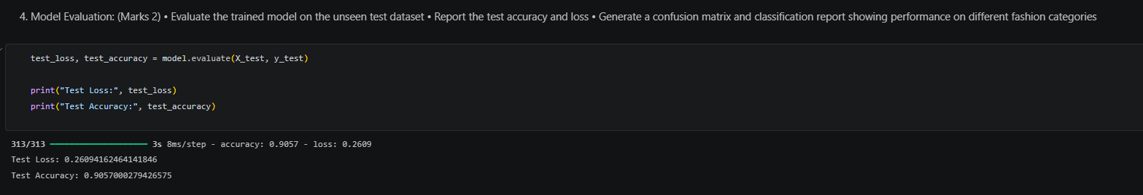
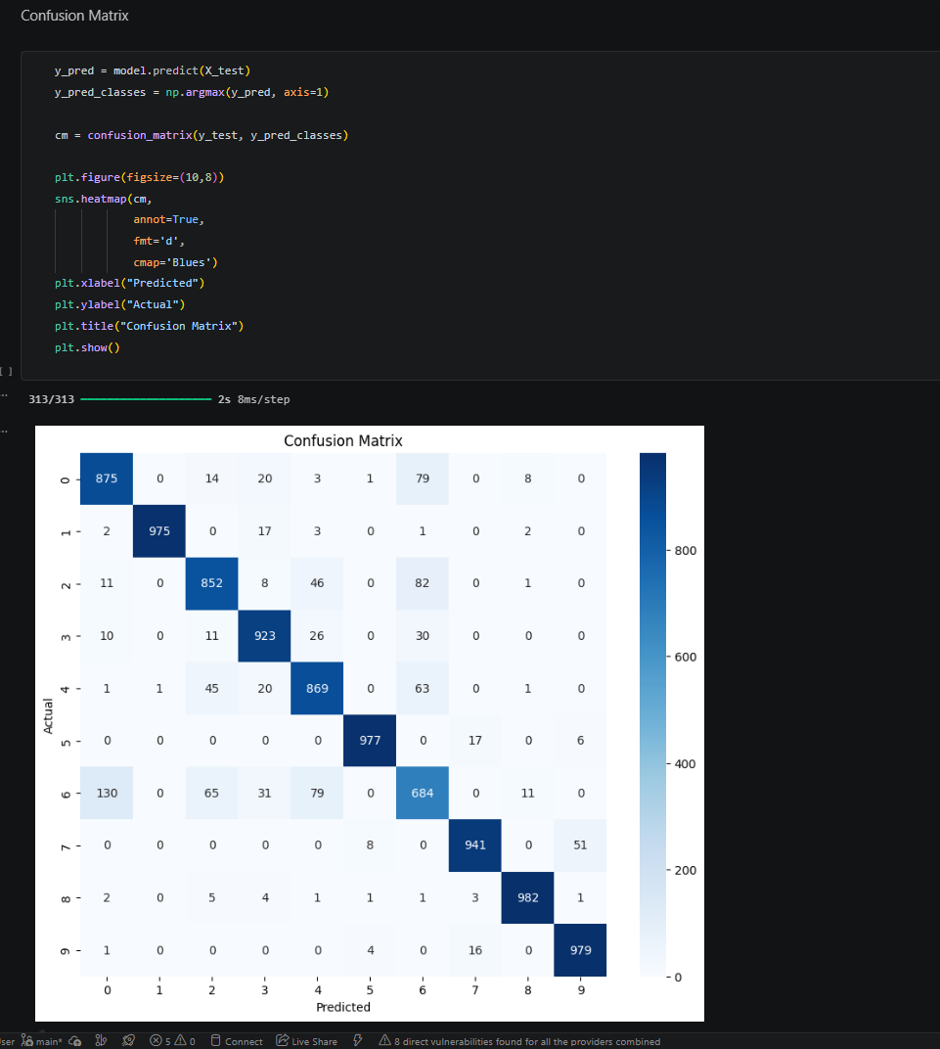
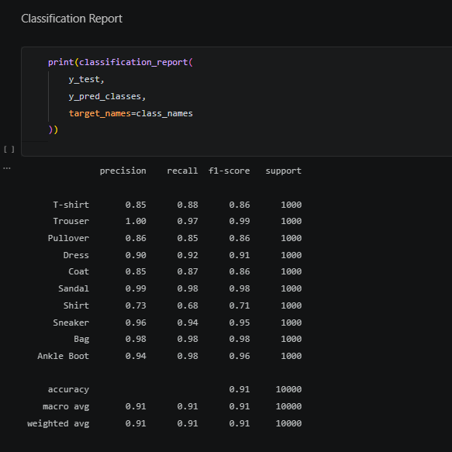
5. Visualization and Analysis of the results
• Plot the training loss and accuracy curves across epochs
• Plot a few test images along with the predicted and true labels
Accuracy Curve
